How to Make a Thermal Flashlight

Ingredients:
1 laptop, 1 USB to Firewire cord, and:
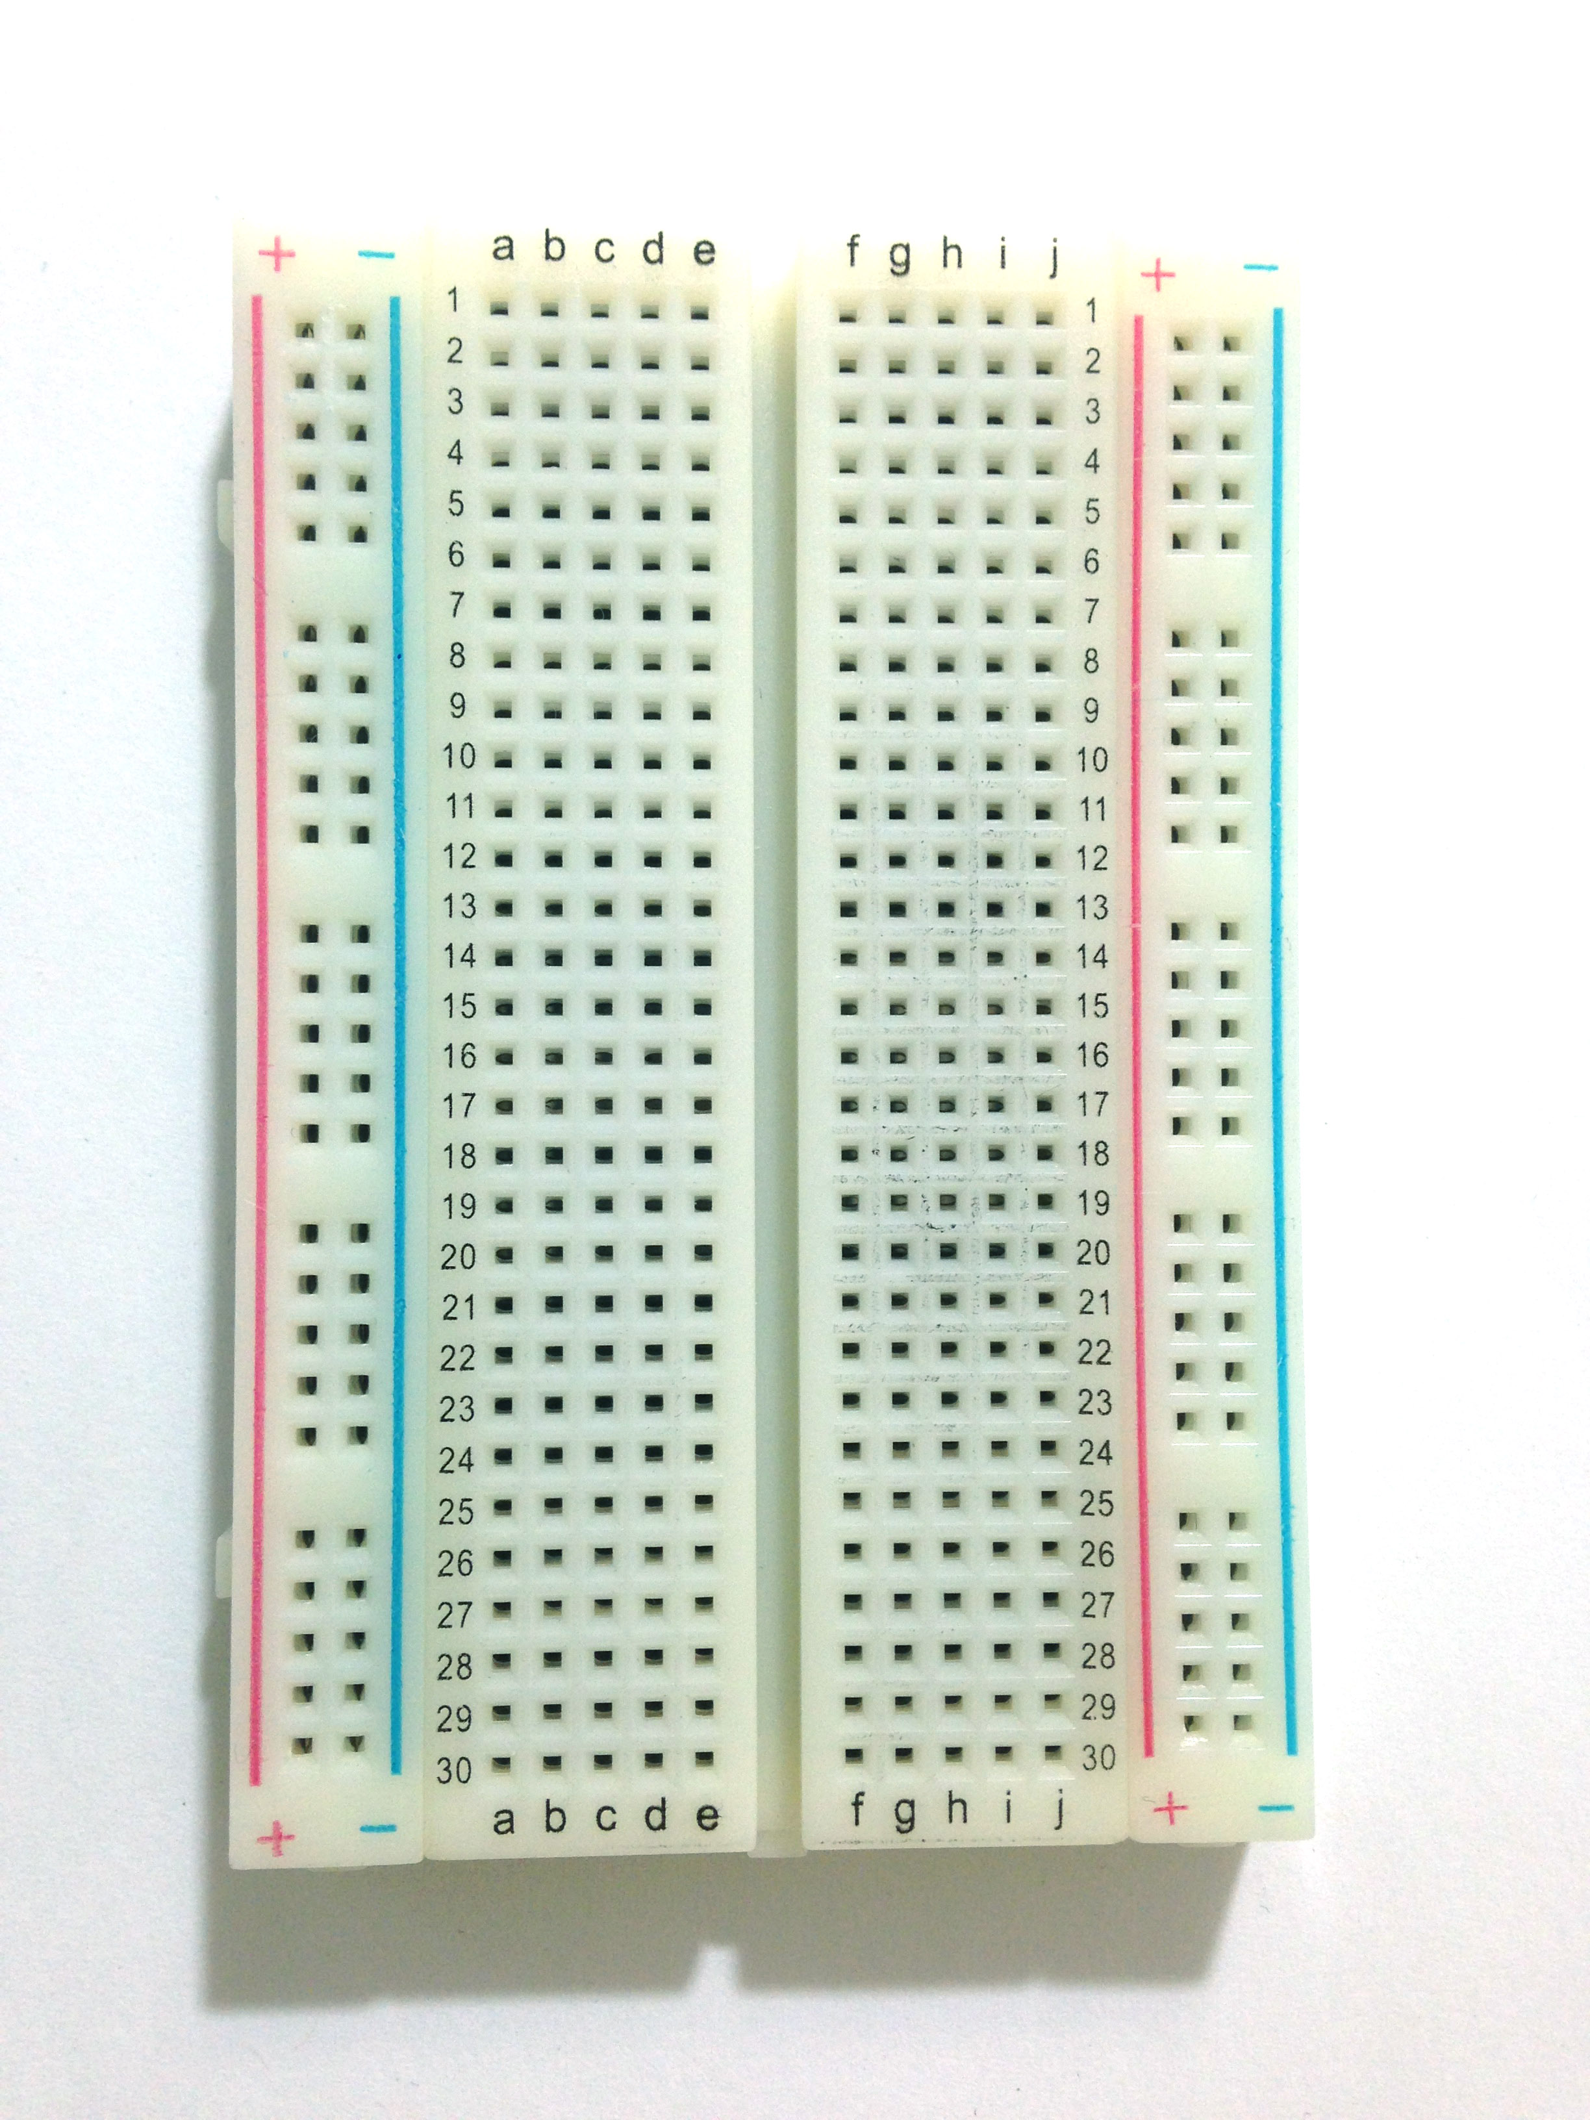  1 breadboard | 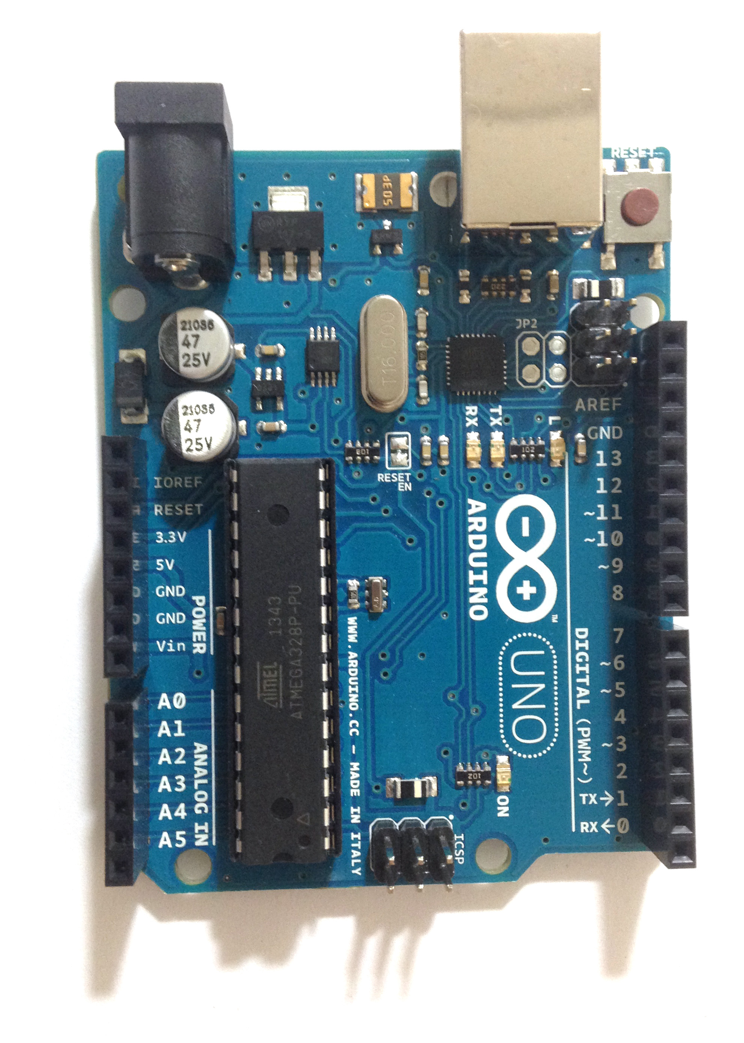1 Arduino | 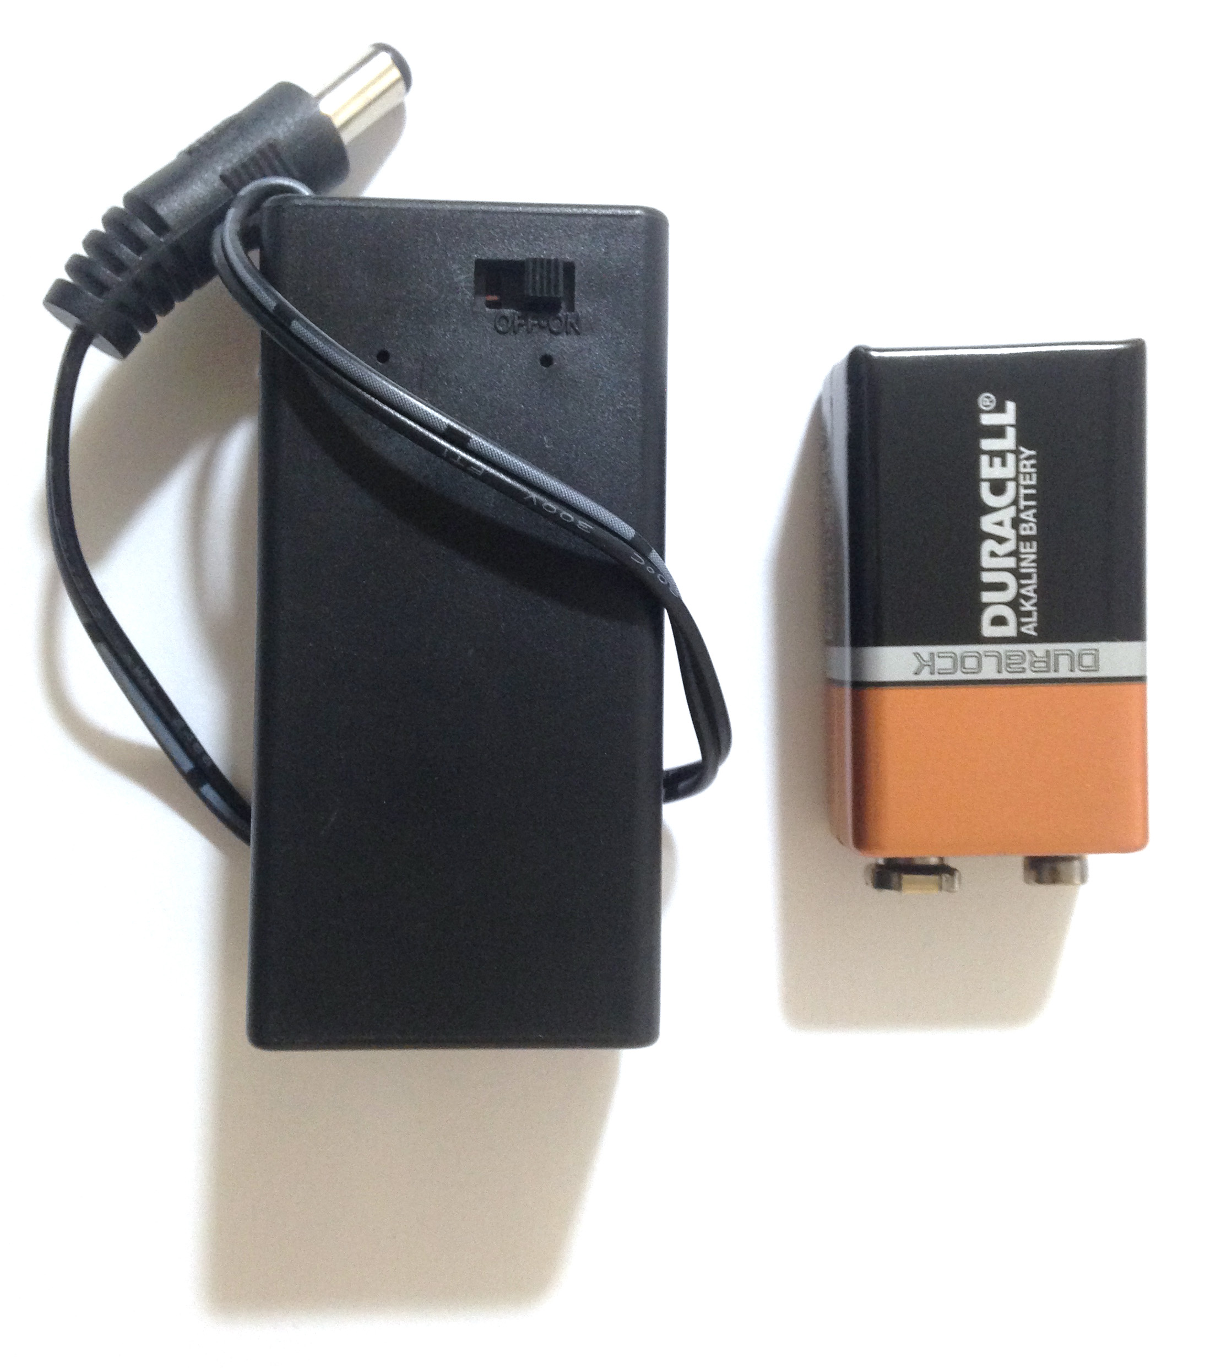  9v battery and holder | 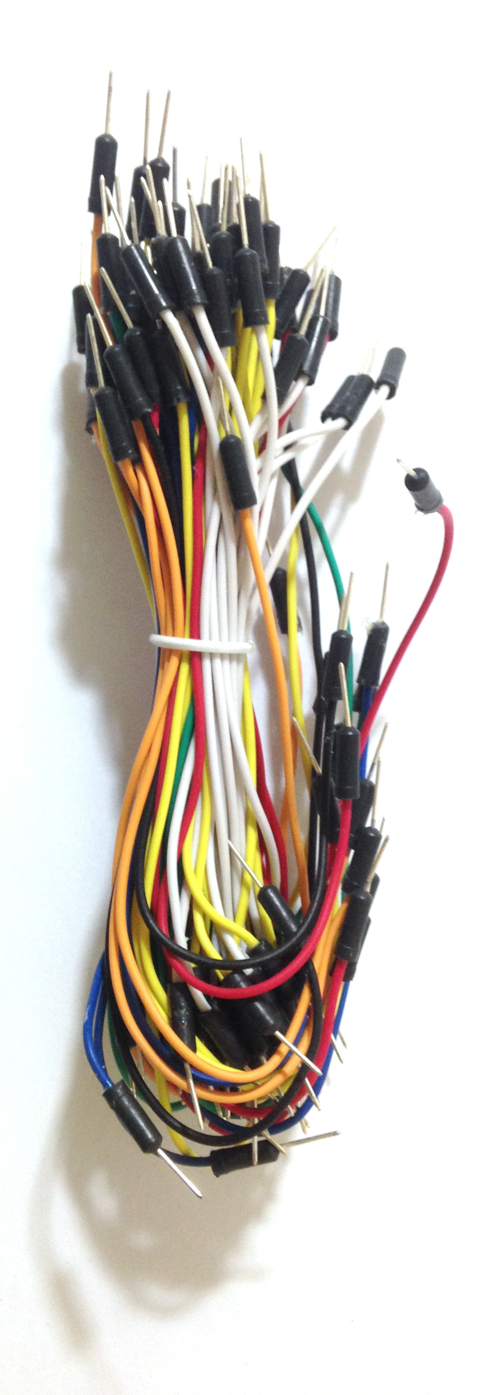  Wires
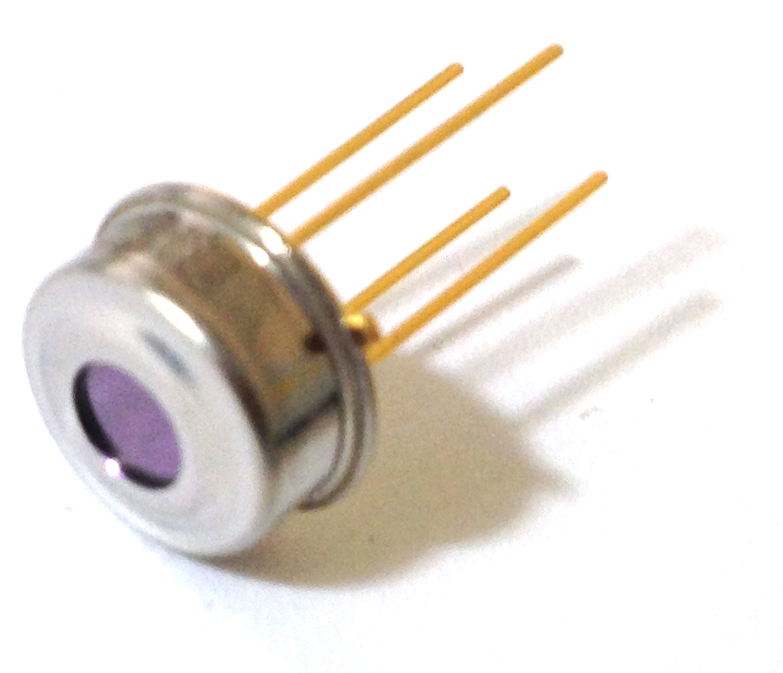  1 Melexis MLX90614 non-contact IR thermometer (3v) | 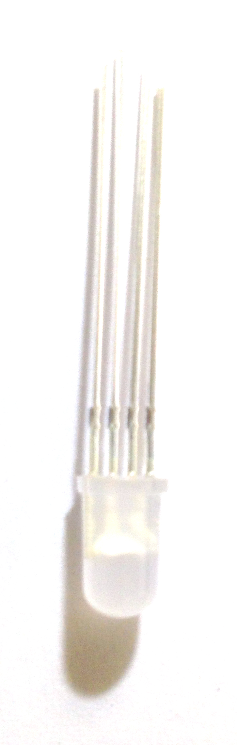  1 RGB common-cathode LED | 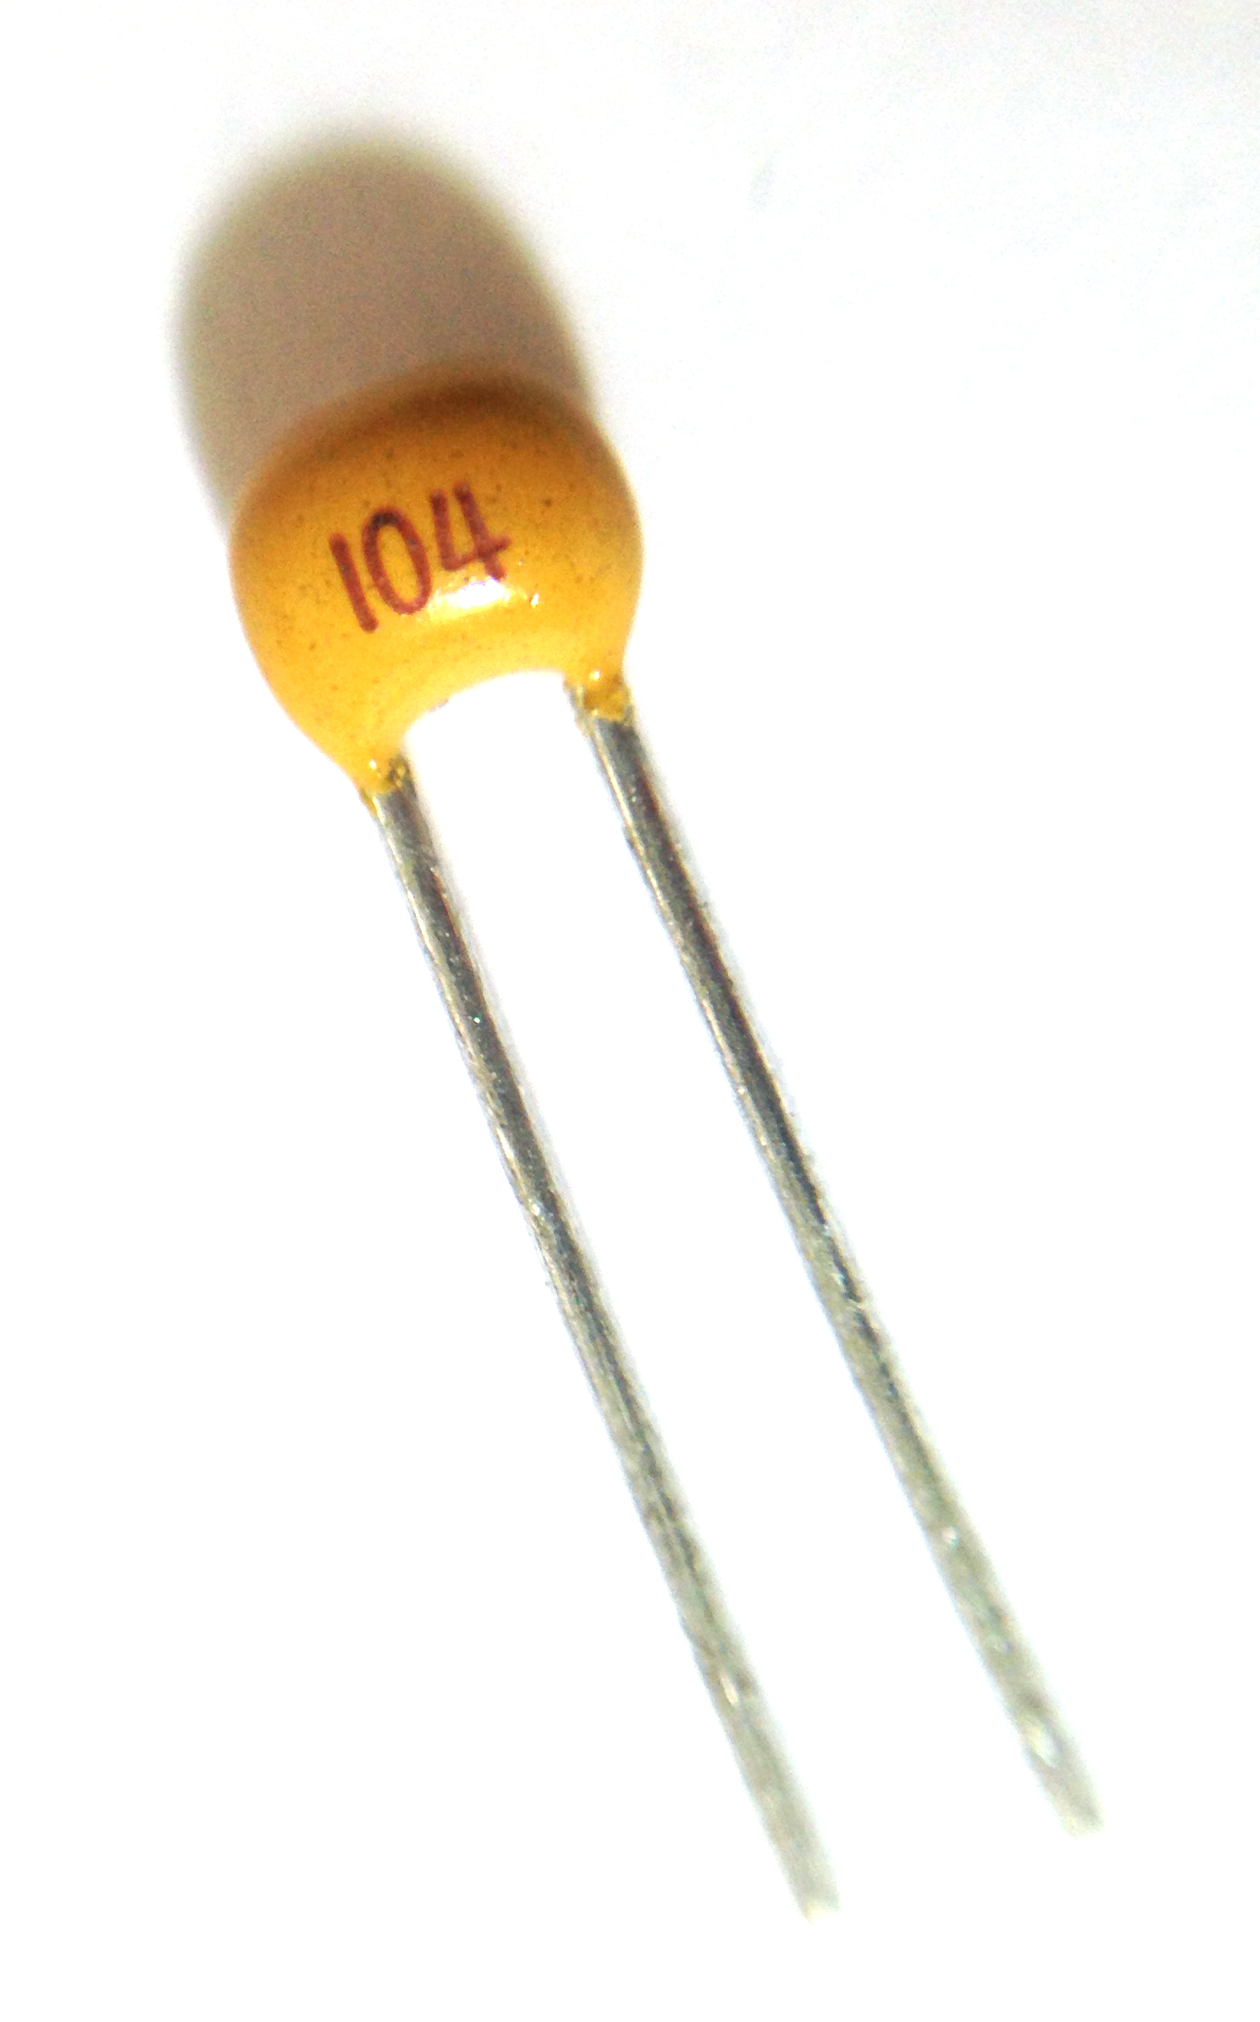  1 0.1 μF capacitor
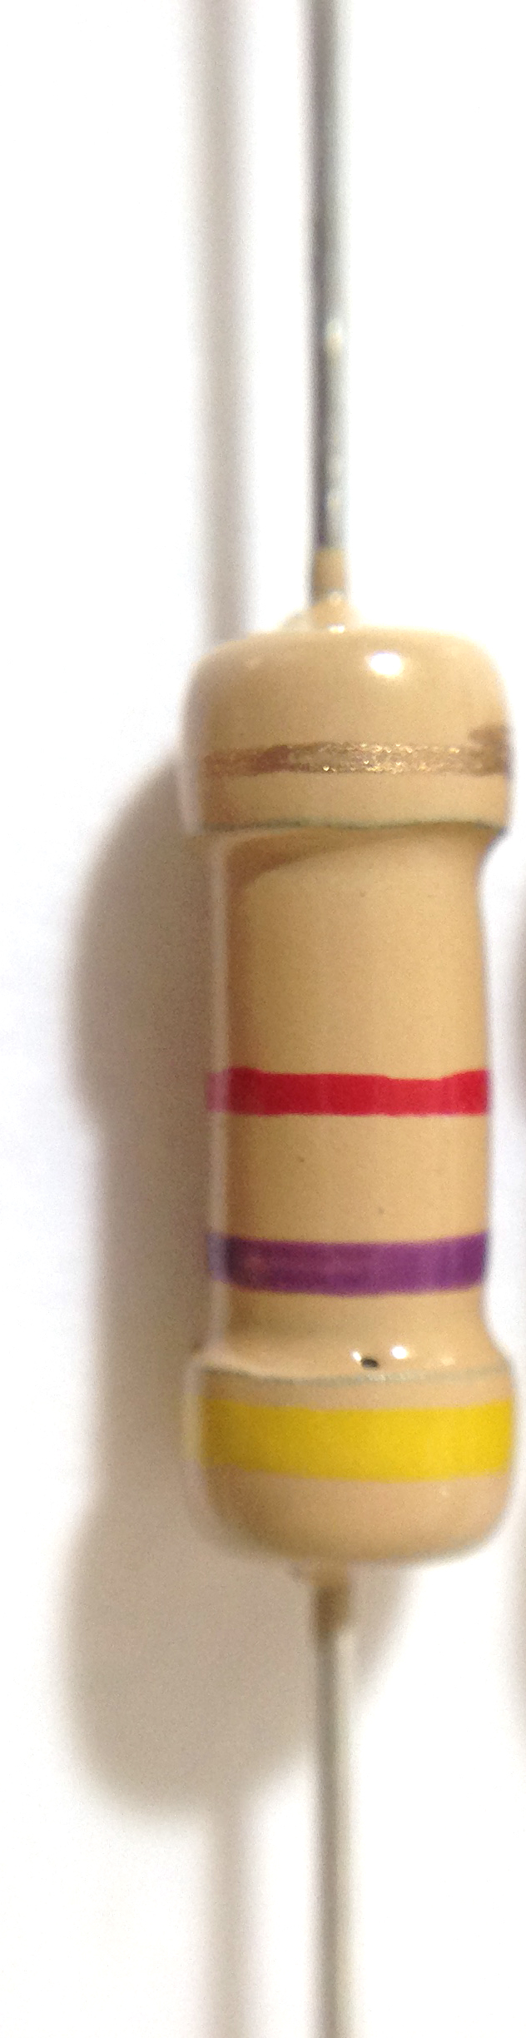  2 4.7k Ohm resistors | 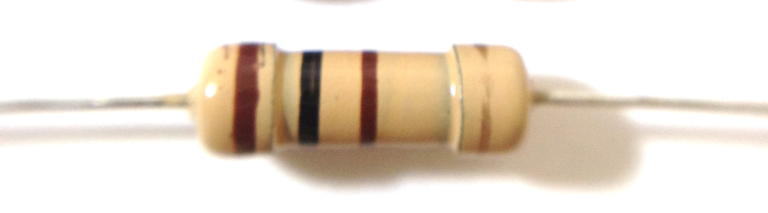  2 100 Ohm resistors | 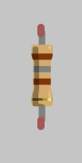  1 180 Ohm resistor

