**Instructions to Make a DIY Thermal Flashlight**

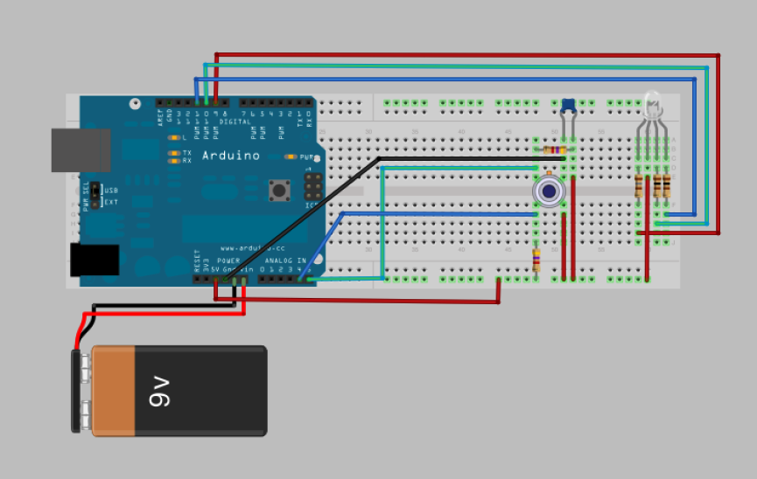

This is a complete circuit. The green shading indicates where electricity is flowing. **ALWAYS POWER OFF THE BOARD WHEN YOU ARE WORKING WITH WIRES.** Electricity flows up and down the bus lengthwise (the red/blue +/- part of the board), and it flows width-wise in the middle of the board (marked a, b, c…). It does not flow over the gulf in the middle of the board.

1. **Place the LED and the thermometer—the two major components—**

**on the bread board**

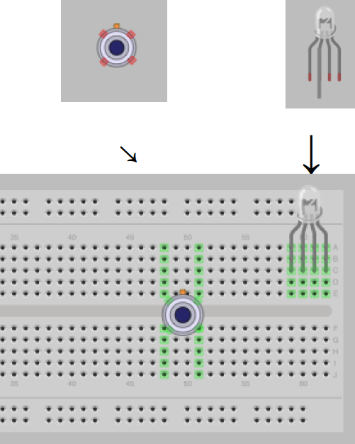The circuit you are building connects temperature readings from the thermometer to different colors of light emitted by the LED through a Breadboard. You will learn later how to set both the range of the temperature and the colors of light emitted by the LED.

Place them relatively close together.   
The flashlight should change color based on what the temperature of the object the sensor points at. So that the light shines on the object whose temperature you are interested in sensing, you should place the LED and Sensor close to each other on the breadboard.

A. Each “leg” of the LED and the sensor should go in one hole of the breadboard.

B. Orient the LED so the long leg (power) is in the

second position from Left to Right

C. The Nub on the sensor should face to 12 o’clock,

this sets the directionality of the legs. The top two legs should go on the “top” side of the gulf in the bread board, and the bottom two should go on the lower side of the gulf.

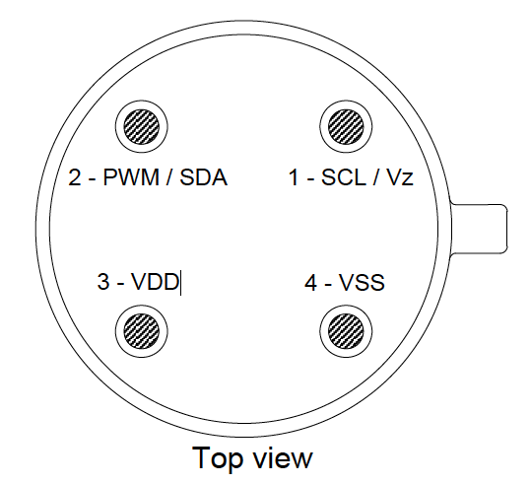

#1 SCL: Input data from Arduino  
#2 PWD: Output temperature to Arduino  
#3 VDD: Power  
#4 VSS: Ground

**2.** **Insert the resistors and capacitors so the correct amount and quality of electricity flows to the major components.**

Select:

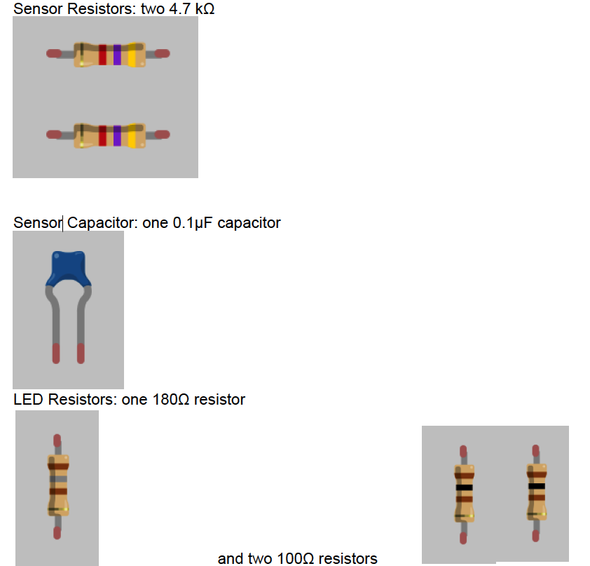

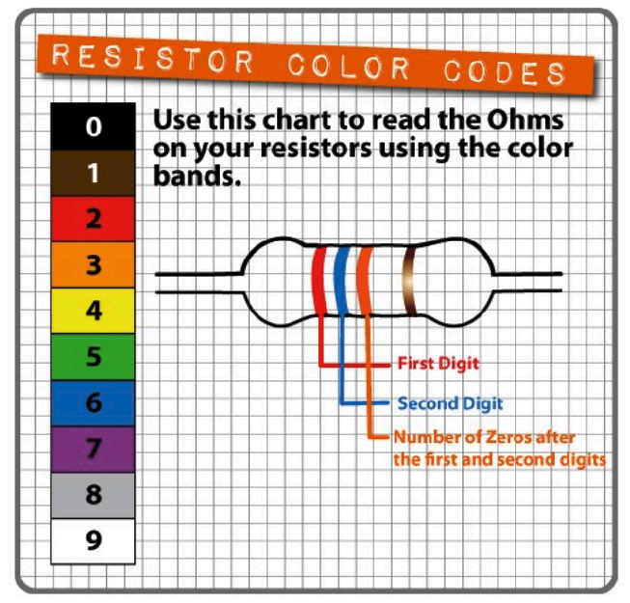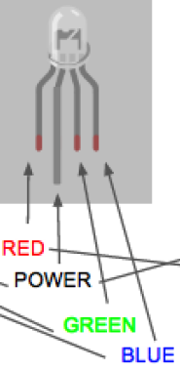

4.7K Ω (yellow, purple, red) goes to the sensor.  
100 Ω (brown, black, brown) goes to green and blue channels.

180 Ω (brown grey brown) go to the red channel.

The 0.1 μF regulates the power to the sensor. Please do not “blow up” the sensor; make sure this is placed correctly.

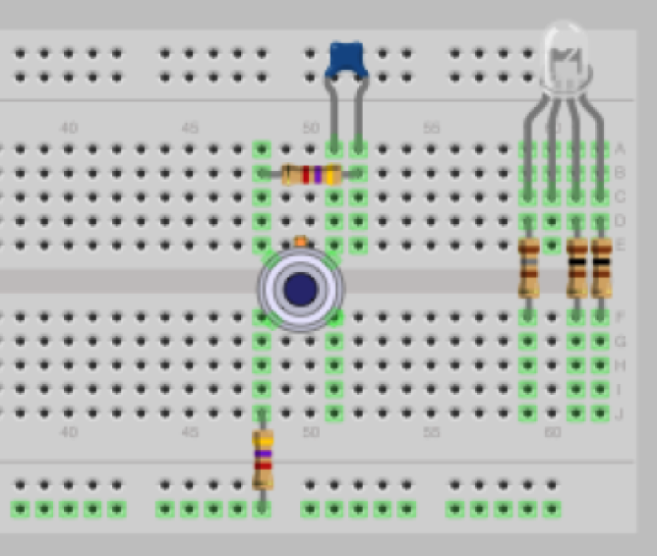

**Next, Connect the bread board to the Arduino!**

It doesn’t matter what colour your wires are, but the diagram uses:

Red- for power in

Black- for ground wire

Turquoise- for data in  
Blue- for data out

**4. Give power to the LED!**

We will run power from the Aurdino to the bus in a moment, but first we will do the finicky wires in the middle of the board first.

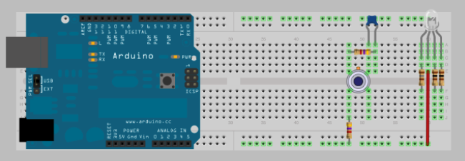

Run a power wire (red) from the bus to the power leg of the LED (second leg—it should not have a resistor on it).

**5. Now connect the LED to the Aurdino…**

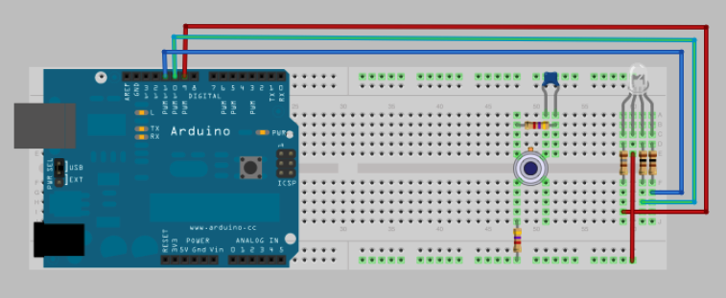

First leg of LED is red- it goes to port 9 on the Aurdino digital outs.   
Second leg of the LED is power. It should already have a wire.

Third leg of the LED is Green- it goes to port 10.  
Fourth leg of the LED is Blue- it goes to port 11.  
* A common mistake is to use port 8. We are skipping port 8 and starting with 9.

**6. Bring Power to the Capacitor, and thus to the Sensor!**

The sensor has a little computer inside it so it needs power to two points.

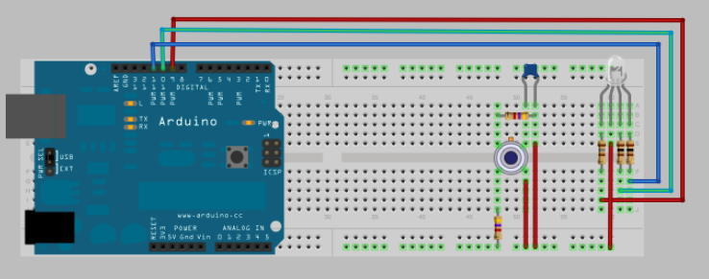

Put a wire from the bus to the right leg of the capacitor and the right leg of the 4.7k resistor.

**7. Bring power and a ground from the Arduino to the Board!**Make sure the Arduino power is not on in any way.

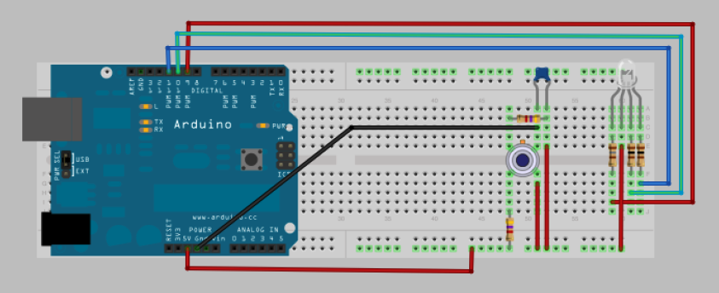  
  
Our sensor needs 5V. Connect the 5V pin on the Arduino to the lower Power bus on the board. Connect the top right leg of the capacitor to the Ground (GND) pin.

**8. Bring Data to and From the Sensor**Connect one wire from the top left leg of the sensor to ANALOG pin 5.

Connect one wire from the bottom left leg of the sensor to ANALOG pin 4.

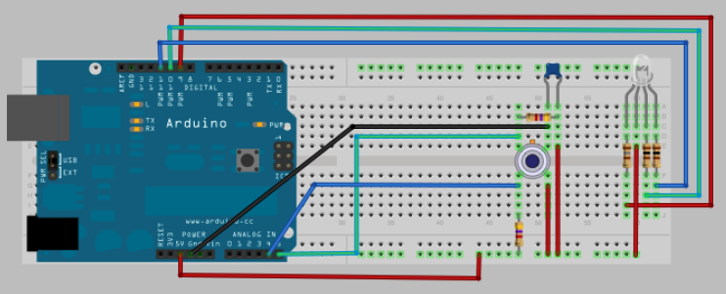

*A common mistake is to use the wrong pins in the Arduino. Make sure they say A5 and A4. Not ~5 and ~4.

**9. Turn on the Power!**

You can plug a USB/fire wire cord from the Arduino to a computer using the fire wire port on the upper left hand side of the Arduino.

Or, you can use a battery pack that attaches to the battery port on the lower left hand side of the Arduino.

Or, you can wire a battery cap. Connect the Black wire to Ground (GRN). Connect Red wire to Voltage in (VIN). (pictured below).

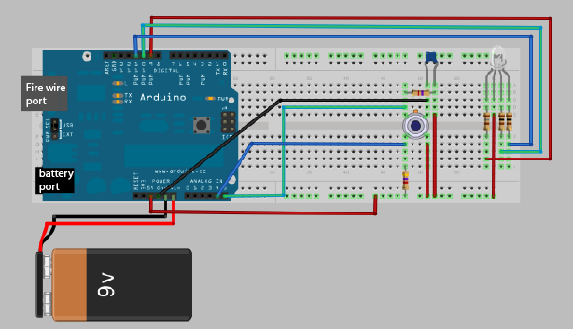

**Troubleshooting common mistakes**

If the light doesn’t come on, you have a connection problem.  
**UNPLUG THE BOARD BEFORE YOU MOVE ANY WIRES**

Check the circuit line by line:

* Line up the legs of the capacitor and resistors
* Make sure wires aren’t crossed
* Do you have missing wires? Count them.
* Did you put the power in the 5V pin on the Arduino? Count the pins going up from the bottom rather than trying to eyeball the pin that is 5V.
* Did you put a digital output wire in pin 8 rather than pin 9 on the Arduino?
* Do your LED resistors jump the gulf on the board ?
* Do both 4.7k resistors have power going to them?

**Software**

1. Download Arduino. [www.arduino.cc](http://www.arduino.cc) > Download > [Arduino 1.0.6](http://arduino.cc/en/Main/Software#toc2)
2. Choose your platform (Windows, Mac OS X, Linux). Click to download.
3. It will download a zip file. Open it and place the application in your Applications /Program folder.  
     < The Arduino Icon
4. Double click the Icon. It opens a text editor.
5. Go to Tools > Board. Select Arduino UNO.
6. Go to Tools > Serial Port > Dev/tty/USB…. If this does not appear, connect the Firewire/USB cord from the Arduino to the computer. If the tty port doesn’t work, try the other one with USB in the name.
7. Close Arduino.
8. Go to <http://bildr.org/2011/02/mlx90614-arduino/>
9. At the bottom of the page, there is a grey inset window with a download button. Download the file.  The file name is MLX90614_Infrared_Thermometer(Arduino)[V19]
10. Unzip the file and open it up. It has a folder called I2Cmaster, two text files (License.txt and Read_me.text) and an Arduino sketch called MLX90614.ino, which if you remember is the name of our sensor.
11. Take ALL THOSE THINGS and drop them in your Arduino Library directly (**not** inside a fielder called MX90617, but as individual folders). Immediately delete MLX90614.ino. This is a sketch built for a different circuit with the same sensor. Confusing, right?!

Forgot where your Arudino library is?  On your Mac:: In (home directory)/Documents/Arduino/libraries On your PC:: My Documents -> Arduino -> libraries

1. Now we are going to get the right code. Open your Arduino.
2. Go to the Public Lab post here: <http://publiclab.org/notes/warren/12-12-2011/circuit-diagram-simple-thermal-flashlight>
3. Copy the code in its entirely into the Arduino window.
4. Validate it (check mark button). It should validate. Save it with a name you’ll remember.
5. Hook up the USB/firewire cable between the Arduino and your computer. *The board now has power going to it, so be careful of that!* The lights on the board will light up.
6. Now, upload the code to the Arduino. Click the upload button (—> button). The software is now on your Arduino.

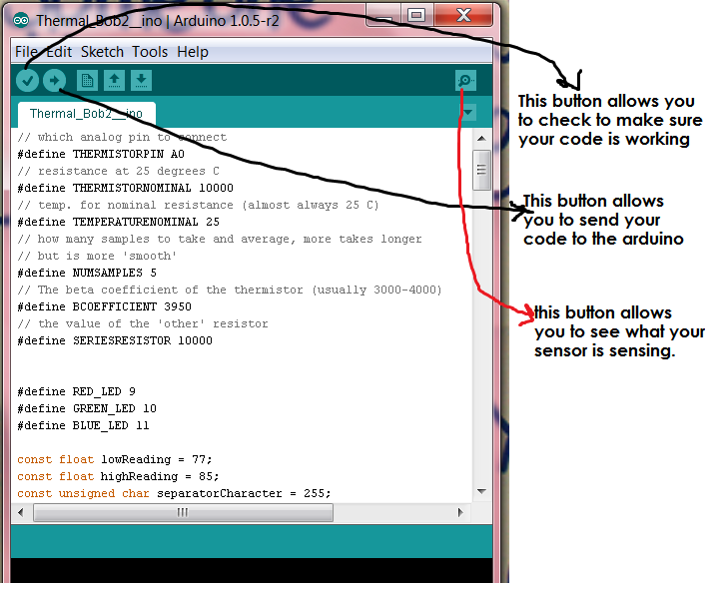

**Changing the Temperature Range**

Your Arduino is telling the temperature RIGHT NOW. To see what the sensor is seeing, press the Serial Monitor Button (top RHS, square magnifying glass button). A stream of temperatures will result. This is the real-time data. You can take your laptop into the field with you to get this information and fine tune your temperature.

To change the temperature range of your sensor, find the area in the code that says:  
const float lowReading = 75; (or some other number)

const float highReading = 80;

These are your high (red) and low (blue) temperature readings in Fahrenheit. You can change them for your temperature range. Try changing the temperature to read different things, like body heat and windows.

Next steps:  
Make a casing!

Go map some temperature!   
Use a light streaking/light painting app, or long exposure photography app or camera to visualize your data.   
Make research notes of your findings and improvements, including your casings.

How to make a research note on Public Lab:

1. [[[http://publiclaboratory.org/join|Sign-up](http://publiclaboratory.org/join%7CSign-up) for Public Lab]]
2. Once you are signed in you can [[[http://publiclaboratory.org/note/add|Start](http://publiclaboratory.org/note/add%7CStart) a Research Note]]
3. Subscribe to Thermal Flashlight project updates, Providence updates or up dates from particular researchers. At the bottom of each research note you can find a drop down menu labelled "subscription". Click that menu you and can subscribe to the author's note, the place and the research theme.