**The P.E.D. R.O.C.K**

(Plastic Eating Device for Rocky Ocean Coasts.)

A Feminist Technology Designed to Capture Ocean Plastics on Rocky Coasts.

By: Cian Kavanagh, Colin Grenning, and Nicolas Brouard-Ayres

Executive Summary:

**Statement of Problem:**

Ocean plastics are a growing concern to many, however there are few technologies in existence that are designed to monitor ocean plastics in parts of the world with rocky ocean beaches. Our device is a feminist technology that was designed for use in these rocky environments where traditional plastic monitoring devices are not viable options. Ocean plastics are a global problem, it is important that information can be gathered anywhere. Our device was designed and built in Newfoundland, an eastern province of Canada known for its rocky ocean coast and windy climate. The coastal conditions in Newfoundland require a specific type of device to successfully gather information on ocean plastics.

**Methodology:**

The P.E.D. R.O.C.K is designed to be able to be used in Newfoundland or similar conditions by people with little to no previous knowledge or training. It is meant to be a cheap easy alternative to expensive monitoring devices, allowing for a greater number of people to create and use it. The Device is composed of a 50x50cm bottomless wooden frame 12 inches deep, with a hinged wooden frame top, covered over with poultry netting. The bottom of the device is composed of two wooden supports intersecting at the center supporting a fine mesh bottom. The device also features an attached pole and flag; the flag is meant to provide information to anyone who happens upon the device while also featuring a contact email for anyone seeking further information. The device is used by being buried in the rocks along the shoreline, below the highest tide. As the tide rises, any surface plastics being pushed ashore find their way into the box. When the tide recedes, water flows out the bottom of the box through the mesh, leaving plastics trapped within.

**Findings and Results:**

The conditions in Newfoundland, in relation the weather and rocky beaches made for a significant challenge in terms of gathering information. However, we were able to gather a sample that we collected between the 9th to the 13th of March 2015 on a beach of the Quidi Vidi Gut. The majority of our sample consisted of small shell fragments, rocks and 4 distinctly human-made items, the most interesting of which being a small plastic covered wire; the very first ocean plastic captured by the P.E.D. R.O.C.K. The other human-made objects consisted of a small cylindrical piece of porcelain, the aluminum tab of a can, and a piece of dark glass believed to be from a beer bottle. Rough seas resulting from strong winds unfortunately took the device before a second sample could be taken. While we were not able to gather a secondary sample, several types of plastics were found on the beach in the area surrounding the last known location. The plastics witnessed on the beach along with the one we caught, indicates to us that there is a presence of plastics in the area where we conducted our testing. We believe that the creation of a new P.E.D. R.O.C.K for use over an extended period of time would generate valuable data. Through the creation and testing of our device, we discovered several changes that could be made to the design of the P.E.D. R.O.C.K that would improve its performance and extend its lifetime.

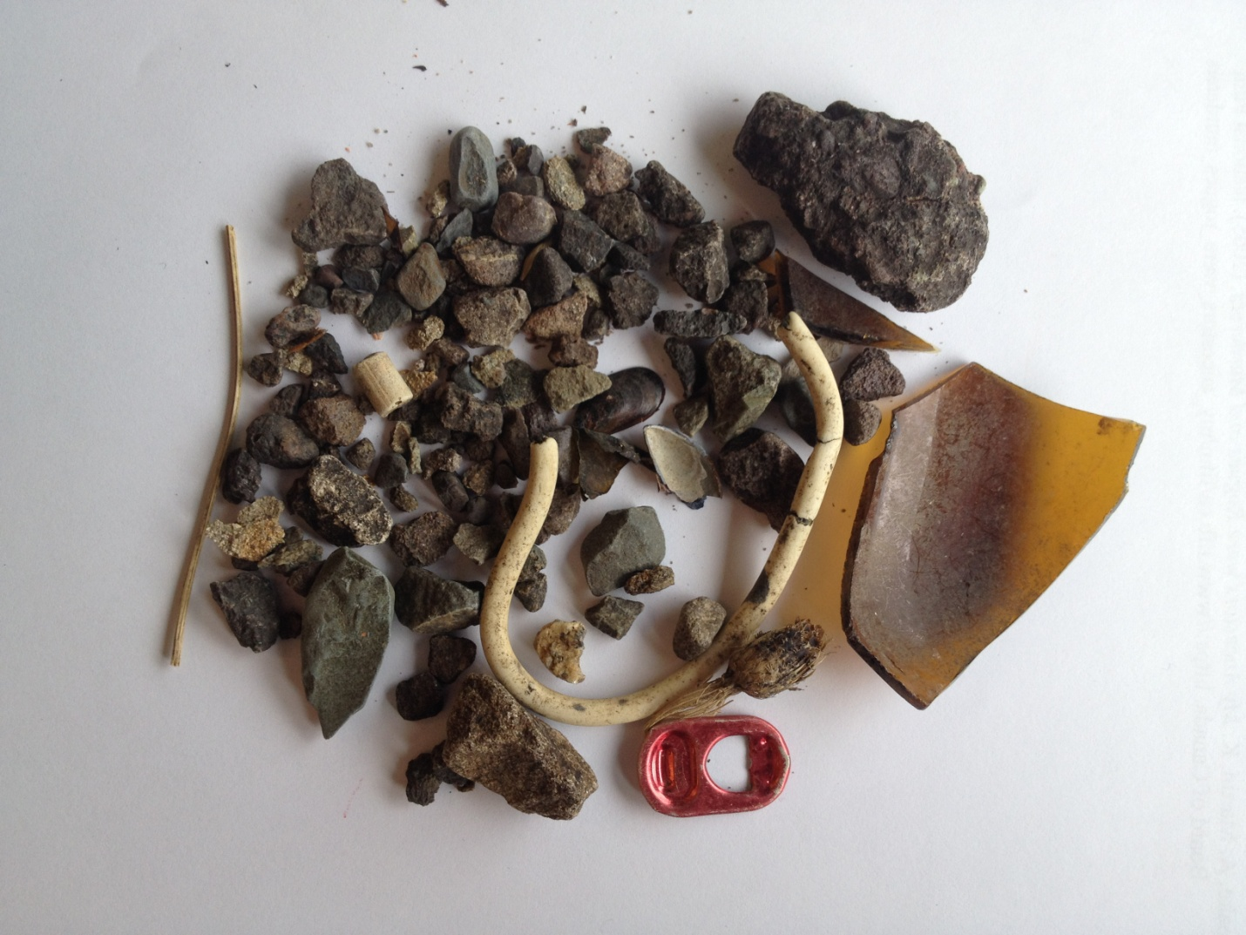

The mixed sample taken March 13th 2015 from the Quidi Vidi Gut.

**The Problem of Ocean plastics:**

Ocean Plastics are a problem worldwide, and the plastic that ends up in the ocean is varied. These plastics range from macro plastics which are larger more visible plastics to micro plastics which are generally less then 5mm in length (Lusher, 2014, p.325). The source of these plastics can be from almost anywhere, often larger plastics are from litter and garbage but many of the micro plastics were intended for industrial use but end up in the ocean, and distributed through ocean currents. Often plastic debris washes up on beaches and coast lines, as Barnes states “Enclosed seas and semi-enclosed seas such as the Caribbean, typically have high densities of plastic debris but also considerable variability. High densities and variability can also be a feature of open ocean coastlines”(2009, p.1988). Plastics can be found in almost every marine environment. Plastics that do not wash ashore often stay in the ocean and generally build up in gyres (Ivar du sol, 2013, p.353). It is important for more research to be done on how the plastics move through the ocean as currently little is known about their movement and the problems they might be causing.

Plastics pose the obvious problems in the environment of being consumed by marine life or causing animals to get caught up in them, however plastics also pose a serious problem when they begin to break down. “plastics’ tendency to sorb (take up) persistent, bioaccumulative, and toxic substances, which are present in trace quantities in almost all water bodies. The constituents of plastics, as well as the chemicals and metals they sorb, can travel into the bodies of marine organisms upon consumption” ( Seltenrich, 2015, p.35). Animals are ingesting these plastics that are in the ocean, and as they break down the animals absorb the toxic substances found in the plastics. This is not only an issue for the animals directly ingesting the plastics as it also travels up the food chain. Seltenrich describes how higher level predators may have higher levels of toxic substances as a result of bioaccumulation, which is the build of this toxic substances as a result of eating prey who have also ingested plastics (2015, p.36).

This can have an impact on human health as well. Various chemicals found in plastics are known to be endocrine disruptors; the endocrine system controls hormones in the body. Even small doses of an endocrine disrupter can have a serious effect on the body, as it is a system that can easily become unbalance (Seltenrich, 2015, p.41). Rochelle, a women we interviewed, is a medical professional in the field of fertility. She expressed concerns about the toxic substances found in plastics and the impact they are having on human fertility, “the world health organization has just decreased normal sperm count in men and one of the factors they think it’s from is environmental factors”.

This is an issue that is especially important in Newfoundland. As a province that once relied on the fishery, many people continue to fish or participate recreationally. Many Newfoundlanders buy fish which is caught locally because it is fresh and is considered it a safe reliable product. However, many people are not aware of such concerns.

**The Design:**

The P.E.D. R.O.C.K is specifically designed to be used on rocky coastlines; a terrain which is very prevalent in Newfoundland. We chose to build a device with such terrain in mind because currently there is no data on how to gather and study ocean plastics in this setting.

How it works:

The metal sieve on the top of the device allows water and plastics to flow in, while keeping beach rocks out. The sieve on the bottom of the device is much finer than the top, so water will drain back out while leaving the plastics trapped within the body. This device is meant to be set in place, left for a period of time, and then retrieved. The flag attached is an easy way to spot the device upon return and also provides essential information about the project to individuals who may stumble upon it during the collection period.

Building Materials and Schematics:

- Ply Wood (Four pieces of 48cm x 30cm) - Wooden Broom Stick

- Nylon Mesh Screen Door (~60cm x 60cm) - Metal Hinge (2)

- Metal Chicken Wire (~50cm x 50cm) - Metal Catch (2)

- 2x4 (Four pieces 48cm; One piece 46cm; One piece 54cm) - Screws/ Power Drill

- Staples/ Staple gun - Plastic Sandwich Bag

- Paper/ Colour Printer

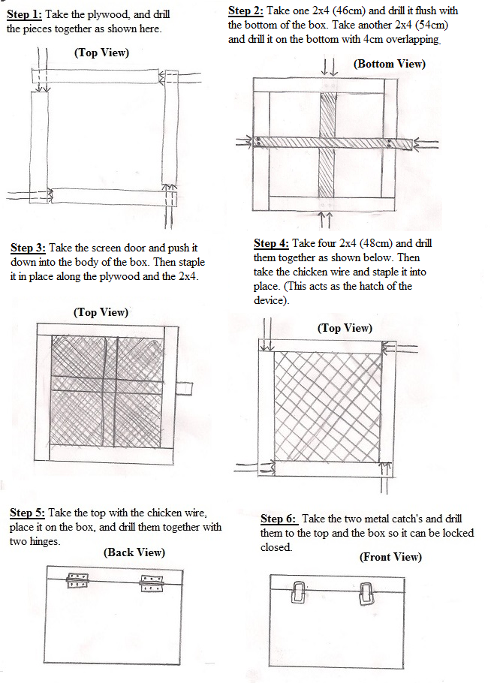

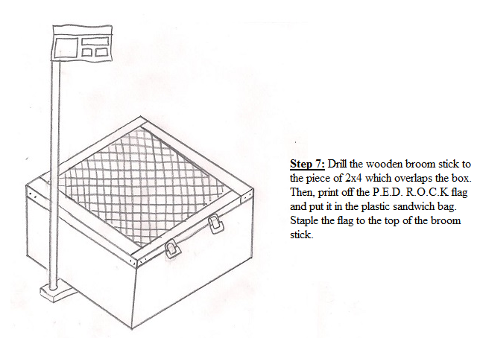

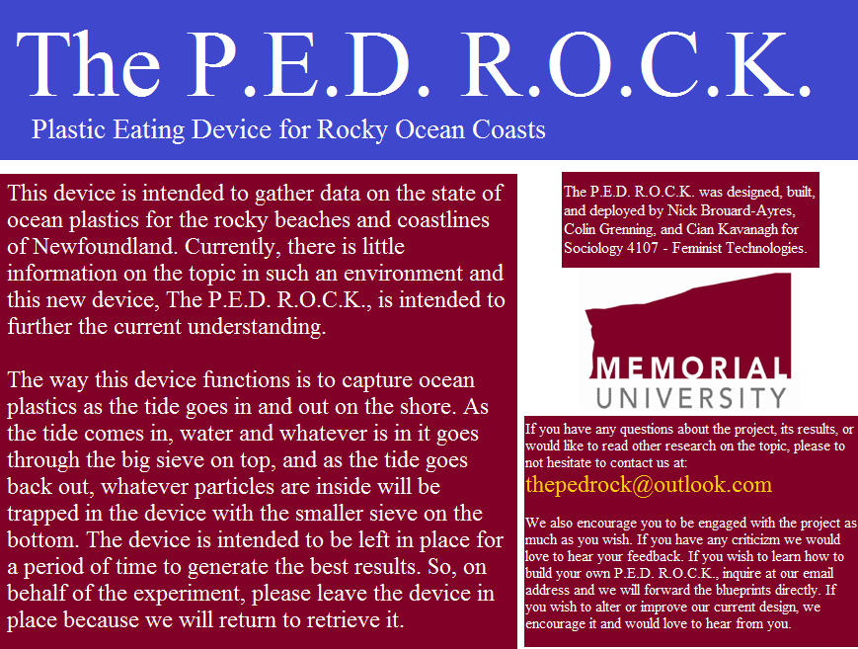

The P.E.D. R.O.C.K differs from other methods of measuring ocean plastics because, as mentioned, it is specific to rocky ocean coasts. Many other devices are intended to be used on sandy beaches, however, the issue of ocean plastics extends beyond such terrain. The device is intended to be stationary and left in place for approximately one week at a time. This method of implementing the device differs from other designs that use the trawl method. Rather than dragging the device through the water, the design allows the fluctuating tide to do the work for us. In the research of Lusher et al, their device differed because they surveyed 12,700 km of water on the open ocean through continuous monitoring below the surface. Such a device is much harder to implement because the individual or group needs access to a boat, knowledge of a more complex device and sampling method, and an extended and continuous commitment of their time. This, we believe, is the complete opposite style of ocean plastics monitoring than the P.E.D. R.O.C.K.

**Our Protocol:**

Use of the P.E.D. R.O.C.K is meant to be simple and can be used by one or more persons. To use the P.E.D. R.O.C.K the first thing that must be done is to choose the location, the device is best suited for rocky beaches where it can be placed between the rocks. The chosen spot should be below where the highest tide reaches, as the device is loaded with plastics via the tides. Once the device is in place, rocks should first be placed along its exterior in a manner that best holds it firmly in place. It is very important to do so as tides have a tendency to move rocks and items that are not properly secured. The next step is to cover in the top of the device in a manner that does not completely seal off the top of the box, but mimics the rest of the shoreline around it. The final step is to affix the flag to the device. The flag is important because it informs passers by the reasons for the box’s presence on the beach. It also provides contract information for anyone interested in finding out more about ocean plastics or the P.E.D. R.O.C.K.

The device should be checked twice weekly to ensure that it is secure against tides and that samples can be taken. To take a sample we simply put on gloves and put every single item present in the device and placed them into a small clear bag. We then visually analyzed all the items in our sample to determine what it was composed of. We had some difficulty determining the composition of one item, and resulted to using a microscope to examine the item in greater detail, which turned out to be porcelain. Had our device not been lost at sea, we would have continued the process for future samples collected. We believe that the device captures plastics at the rate in which they are naturally loaded onto the beach by the tides. Had we been able to prolong our study and gather multiple samples, we could have gathered information as to how much and how quickly plastics are loading onto the beach. The loss of our device also prompted us to attempt to find ways to better protect the device from the elements, ensure it remains in place, and that samples are not able to escape once they enter the device. In the future we hope to be able to build new prototypes based off the original P.E.D. R.O.C.K that will be even more effective in the monitoring of ocean plastics.

When we designed the P.E.D. R.O.C.K we intended to have feminist values baked into our technology. Donna Haraway discusses “situated knowledge’s” and “local Knowledge”, which we drew from to help us design a technology that would work in Newfoundland. This addresses the fact that as Newfoundlanders we have a different experience then others studying ocean plastics. Much of the writing on ocean plastics has been based on sandy beaches in summer weather. During the month of March in Newfoundland, we did not have that advantage and most of the technologies and procedures used in other research would not be successful here. We have a much colder climate then the areas in which other studies have been done, with rocky beaches, wind, and ice. We had to use our own experience to create knowledge that could be used towards building our own technology to catch ocean plastics. Haraway describes that "I am arguing for politics and epistemologies of location, positioning, and situating, where partiality and not universality is the condition of being heard to make rational knowledge claims."(1988, p.589). We understood that unlike on sandy beaches we were unable to simply scoop a sample of sand, so we designed a technology that was more appropriate for Newfoundland’s rocky beaches. Through trial and error we were able to find that possibly smaller plastics could be found under rocks and therefore in order to be able to get any plastics we would have to make a device that we could place under the rocks.

Another aspect we wanted our technology to have was for it to be open source, we felt this was important because Newfoundland is a province that culturally has close ties to the ocean. Many Newfoundlander’s consume local fish which have been exposed to ocean plastics and its hazards, so a project on ocean plastics could be quite important to the community. Along with our actual technology we included a flag with information about what the technology was and our goals. The flag was a way to add feminist values to our technology in that we were able to allow people to ask questions rather than just provide a quick statement about what our technology is. Virginia Eubanks discuses her time at the YWCA of Troy-Cohoes, and her attempt at various projects. One of her projects failed to deliver the end result she expected, however she does point out that it achieved a lot more through the process of the project. She states “the environment created by peer-learning, the value placed on participants knowledge and life experience, and the open and transparent nature of our process produced many of the formative insights upon which our book is based” (2011, p.119). We included an email so people could get in contact with us if they had questions. This allowed people to get more information on what we were doing if they were interested, possibly giving us some of their own knowledge on the area. This knowledge could have potentially improved our design and show us a perspective we may have not considered. As a result of location and weather it is possible no one saw our technology to email and ask questions, however under different circumstances we hope to be able to open up a discussion with the public.

**Findings:**

Our findings on ocean plastics in Newfoundland were collected during a five-day period (March 9th to 13th, 2015.) in ‘The Gut’ of Quidi Vidi. Since there is little research on ocean plastics in Newfoundland, our findings provide a lot of new information on the subject local to the province.

What We Caught:

From this one-week period we managed to catch a range of materials in the P.E.D. R.O.C.K. Most of our sample was rocks and small shells, however there were four distinct human-made objects. These included an electrical wire (~130mm long and 5mm wide) that was coated in plastic, the tab of a drink can, a shard of class from a beer bottle, and a small piece of what we believe to be porcelain (9mm x 6mm).

Along with what we caught in the device, we also found a number of other examples of plastics and human-made objects along the shoreline. This included a shoe, more electrical wire, rubber tubing, a teddy bear, as well as some micro plastics (smaller than 5mm).

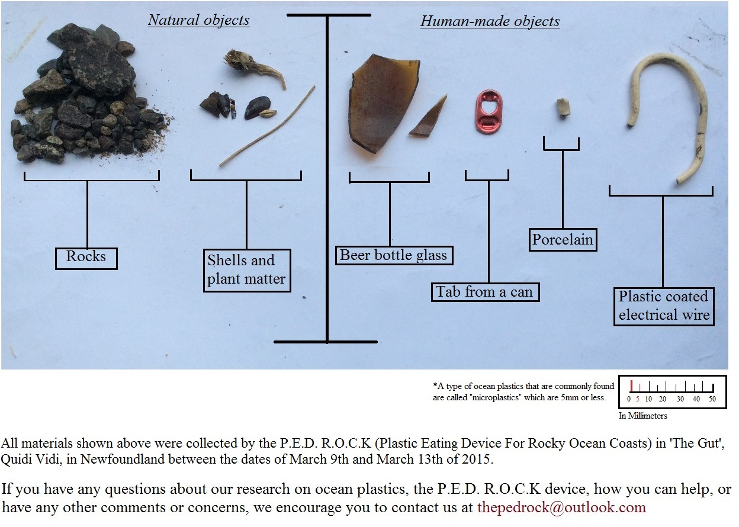

From this trial we have concluded that there are plastics on this particular beach and in the water, and that the P.E.D. R.O.C.K does in fact work. However, we also concluded that Newfoundland weather and terrain are an issue when collecting a sample.

Newfoundland Geography:

Since we were conducting the study in March, the weather was not ideal. The particular location we decided to use was very rocky, and due to the low temperatures they were often covered with ice. This made it difficult to walk along the beach, especially while carrying the device. After the ice thawed off of the rocks is when we found the other plastics. So we conclude our findings may be skewed because some plastics were frozen onto the shoreline. In the warmer summer months these plastics would be more mobile in the water, and perhaps more plastics would wash up.

While the device was left in place, it too became covered in ice. The sieves still worked, however the ice may have made collection more difficult. Once again, the summer months would allow the device to work better.

Our first five-day trial run went successfully and we obtained a good sample. However, we put the device out for another five-day period to gather more data, and upon return the P.E.D. R.O.C.K was missing. During that week we had some high winds and believe the device was washed away into. This is an unfortunate occurrence, however it is also a learning curve. This made us realize that the device can be updated to include a way of securely fastening it down.

**Conclusion:**

During the course of our design, research, and use of the P.E.D. R.O.C.K we have gained valuable knowledge about ocean plastics and how to monitor them in Newfoundland. The weather and geography in Newfoundland posed a unique challenge to gathering information and samples. We used our own experiences as Newfoundlanders to build a device that could stand up to the unique conditions of the island. Being Newfoundlanders we believe that we would be ideal candidates to continue research in the area. We would continue either through MUCEP (Memorial Undergraduate Career Experience Program) positions with Dr. M. Liboiron, independently, or through others using our design with their own variations. The P.E.D. R.O.C.K was successful in its intended purpose, however as we have indicated, improvements can be made for future use. The device is licensed under a creative commons allowing others the opportunity to create their own versions of the P.E.D. R.O.C.K specific to their own needs.

Works Cited:

Barnes, D. K. A., Francois G., Thompson, R. C, and Barlaz, M. (2009). Accumulation

and Fragmentation of Plastic Debris in Global Environments. *Philosophical*

*Transactions of the Royal Society B: Biological Sciences,* 364(1526),1985–98.

Eubanks, Virginia. 2011. Digital Dead End: Fighting for Social Justice in the Information

Age. MIT Press.

Haraway, D. (1988). Situated Knowledges: The Science Question in Feminism and the

Privilege of Partial Perspective. *Feminist Studies,* 14(3), 575–99.

Ivar du sol, J. A. (2014). The present and future of microplastic pollution in the marine

environment. *Environmental pollution*, 185, 352-364.

Lusher, A. L., Burke, A., O'Connor, I., & Officer, R. (2014). Microplastic pollution in the

northeast atlantic ocean: Validated and opportunistic sampling.*Marine Pollution Bulletin, 88*(1-2), 325-333.

Seltenrich, N. (2015). New Link in the Food Chain? Marine Plastic Pollution and

Seafood Safety. *Environmental Health Perspectives,* 123(2), 35-41.

::Desktop:88x31.png  
The P.E.D. R.O.C.K by Cian Kavanagh, Colin Grenning and Nicolas Brouard-Ayres is licensed under a [Creative Commons Attribution-NonCommercial-ShareAlike 4.0 International License](http://creativecommons.org/licenses/by-nc-sa/4.0/).  
Permissions beyond the scope of this license may be available at [thepedrock@outlook.com](http://creativecommons.org/choose/thepedrock@outlook.com).